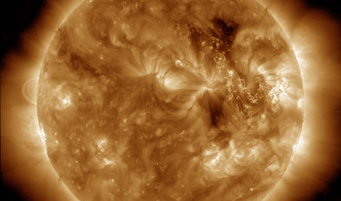
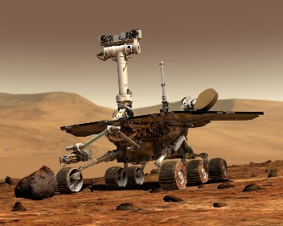
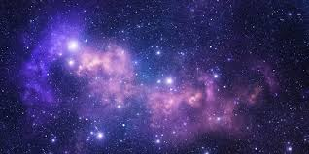
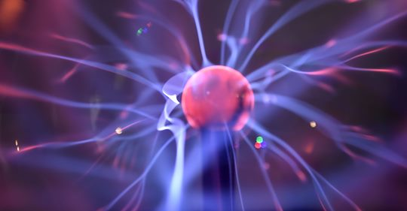
Draw a line to match up the word with its correct definition!
Fusion vocabulary labels
Sun |  | This powers lots of our modern day technology. It is created by generators which can be powered by coal, wind, solar or nuclear energy.
Star |  | A person who uses science and maths to design, build and improve things
Electricity |  | The outer area where all the planets, stars, galaxies and other objects are found.
Pressure |  | The building blocks of all matter. Everything is made from them.
Magnet |  | The star at the centre of our solar system. It gives off heat and light, and is powered by fusion energy.
Energy |  | The reaction that occurs in stars.
Density |  | The amount of force pushing on an object.
Fusion |  | A test or trial to discover something new/ unknown.
Space |  | Enables things to change and move. It’s everywhere around us and takes all sorts of forms.
Experiment |  | A measure of how tightly the mass of an object is packed into the space it takes up.
Engineer |  | A very large and bright ball of super-hot gas.
Atom |  | This has a north and a south pole. These can be attracted to or repelled by other objects.

Answers
- Sun – The star at the centre of our solar system. It gives off heat and light and is powered by fusion energy.
- Star – A very large and bright ball of super-hot gas.
- Electricity – This powers lots of our modern day technology. It is created by generators which can be powered by coal, wind, solar or nuclear energy.
- Pressure – the amount of force pushing on an object.
- Magnet – This has a north and a south pole. These can be attracted to or repelled by other objects.
- Energy – Enables things to change and move. It’s
everywhere around us and takes all sorts of forms.
- Density – A measure of how tightly the mass of an object is packed into the space it takes.
- Fusion – The reaction that occurs in stars.
- Space – The outer area where all the planets, stars, galaxies and other objects are found.
- Experiment – A test or trial to discover something new/ unknown.
- Engineer – A person who uses science and maths to design, build and improve things.
- Atom – The building blocks off all matter. Everything is made from them.

