
Special Techniques Group
Building D4/05
Culham Centre for Fusion Energy
Abingdon
Oxfordshire, OX14 3DB
Direct Line: 01235 466777

Date:
STG job number: | Q20xxx
Customer:
Organisation:
Assembly ID: | 01 | Quantity: | 1

Many thanks for your recent enquiry for the manufacture and supply of bespoke re-entrant viewports.

It would assist greatly in the quotation process if you could fill out the following tables to confirm your critical viewport parameters (If your constrained dimension is not labelled, please include any additional constraints in the blank spaces provided). Please fill out a separate response form for each unique assembly and indicate the quantity required above.

It is preferred to leave any non-critical dimensions blank, or include a range where there is a loose constraint, to allow some design freedom. Any unspecified dimensions will be confirmed after receipt of order in the final design drawings.

An ordering timeline indicating the actions of all parties is included below to clarify the ordering process. Our standard terms and conditions are also included for reference.

End User Statement | Brief statement of end use regarding R&D, scientific experiment, medicine, military use, industrial production etc
Is this assembly for military use:
Please confirm you have read the Terms & Conditions (STG_ADM_016 B) below:

Ordering timeline

Party | Action
Customer | Initial inquiry
STG | Confirm feasibility and provide Inquiry Response
Customer | Provide design criteria on Inquiry Response
STG | Provide quotation based on design criteria
Customer | Place purchase order
STG | Provide final design drawings for customer review
Customer | Confirm acceptance of design
STG | Manufacturing begins

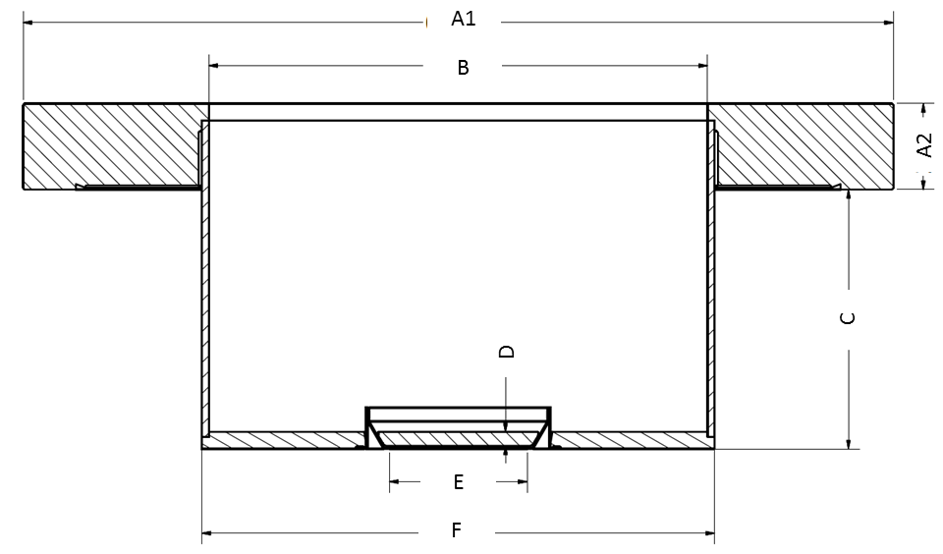
Figure 1: Viewport typical dimensions

Table 1 - Geometric

Label | Content | Example | Customer Requirement
A1,2 | Vacom CF Flange | DN100CF
B | Tube ID | 66 mm
C | Flange exterior to endplate* | 41 mm
D | Optic thickness | 6 mm
E | Optic clear view (CV) aperture | 60 mm
F | Tube OD | 70 mm
See standard constraints in table below, these design rules can be relaxed on request, but it will likely result in greater risk and cost
* Note the optic is recessed slightly from the end of the tube (as mentioned in constraint 10), please mention if the optic position requires tight control

Table 2 - Constraints

Constraint | Content | Standard/Limit
1 | ((F – B) / 2) Tube wall thickness | Min. 2 mm
2 | Tube endplate thickness | Min. 5 mm
3 | (E) Standard optic clear view (CV) aperture sizes | 7, 14, 24, 29.5, 38, 40, 44, 50, 60, 73.2, 87.7, 95, 126, 140, 160 mm
4 | (D) Optic thickness, 7cv – 50cv | Min. 5 mm
5 | (D) Optic thickness, 60cv – 73.2cv | Min. 6 mm
6 | (D) Optic thickness, 87.7cv – 95cv | Min. 8 mm
7 | (D) Optic thickness, 126cv – 140cv | Min. 10 mm
8 | (D) Optic thickness, 160cv | Min. 17 mm
9 | (C) Re-entrant length | Max. 200 mm
10 | Optic recess from endplate | ~0.7 mm
11 | (F – E) Optic support structure | 20 mm

Table 2 - Material

Material Parameters | Standard | Special Customer Requirement
Flange and metalwork | Stainless Steel 316
Optic ferrule | Inconel 625/Tantalum
Optic material | Fused Silica  (Hereaus Spectrosil 2000)
Optic flatness (TWE) * | Transmitted Wavefront Error (TWE) PV: Lambda/8
Optic parallelism (tilt) | < 3 arc minutes
Optic polish * | 80/50 Scratch/Dig
* Optic finish parameters are measured before bonding. No optic parameters can be guaranteed after bonding except in the case of specific development and inspection trials. Optic properties are specified over 90% aperture (clear view)

Table 3 - Anti-Reflection (AR) coating

Coating Parameters | Standard | Customer Requirement and maximum R tolerance
Double-sided | Yes
Angle of Incidence | 0 degrees
Wavelength 1  (In order of priority) | e.g. 400nm, R_max 1%
Wavelength 2 | -
Wavelength 3 | -
Wavelength 4 | -

Additional details / sketches

With kind regards,

Martin Cuddy
Special Techniques Group

